TimeSprite

Status Reports and Project Submissions

Date: 11/11/2016 to 14/12/2016

University of the Pacific

COMP 191, Senior Project, 2016 Fall ---Yunpeng Zhang

Contents

2 Project Schedule 2

3 Currents Status 3

3.1 Finished Tasks 3

3.2 Falling being schedule 3

4 Plan for next work period 4

4.1 Task for next work period 4

5 Challenges and concerns 5

6 updated artifacts 6

# Project Schedule

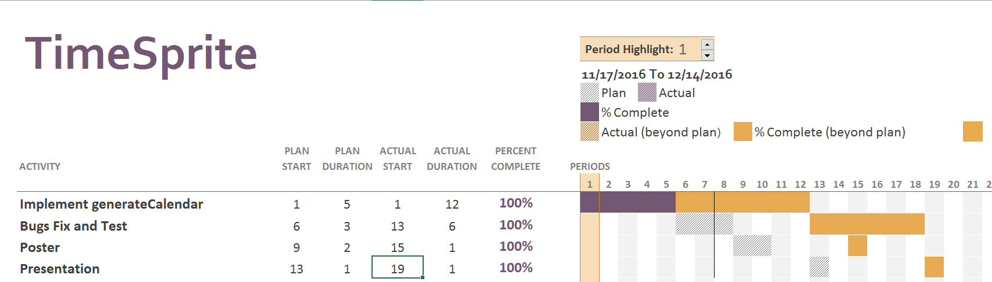

# Currents Status

## Finished Tasks

* Implement GenerateCalendar Class
* Project Post
* Test and Debug
* Presentation

## Falling being schedule

* All tasks had been finished

# Plan for next work period

## Task for next work period

This project is finished and met the basic functional requirements. But it still has some points need to polish and improve. In the feature time, I will continue work on it, and publish to App store.

# Challenges and concerns

The most difficult problem is access IOS system Calendar. The CVCalendar model can not access and update system calendar automatically. I will try to write a new model and package to solve this problem.

# updated artifacts

Artifacts package include:

* Requirements Analysis Document
* System Design Documents
* Functional requirements
* Presentation and Demo
* Source code